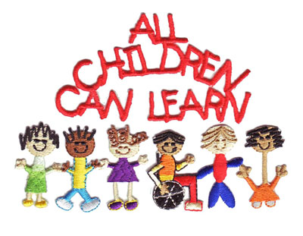
HOME HELPS ARE IMPORTANT!!

It has been shown in research that children who do speech and language home helps progress more rapidly. They are able to remediate faster which then reduces the time they spend in communication therapy. They remember and generalize their skills much easier. Remember that it is much better to practice 5-10 minutes daily as consistently as possible, than it is to practice 30+ minutes 1 time a week.

Make home practice simple and fun. It can be done within your regular routine such as in the car on the way to a sports event, while playing games, while going to the grocery story, reading out loud or simply telling about what happened at school. Children can earn stickers or tokens for each practice day to earn simple reinforcing rewards such as video game time, special time with mom or dad, an extra trip to the library to get books, several M & M’s or other treats, etc. You know the simple things that make your child happy. This can encourage practice with a bit of fun.

Remember that communication therapy provides the specialized teaching of the skill and some minimal practice. As members of the team, parents and the child have the main responsibility to carry out the practice of the skills learned. This makes communication therapy much more effective. Just as learning to do well in sports, music, or dance, takes practice and effort, so do speech and language skills. There are no easy shortcuts so be persistent and consistent with home helps to be successful. If there are things you don’t understand about homework given don’t hesitate to call or email me.

